# **Name: Abdurrahman Qureshi**

# **Roll No: 210451**

Practical No: 30

**1) WAP to draw 3 concentric circles**

**CODE:**

import java.awt.*;  
import java.applet.*;

public class Main extends Applet {

public void paint(Graphics g) {

g.setColor(Color.red);  
 g.drawOval(50, 50, 200, 200);  
 g.setColor(Color.green);  
 g.drawOval(100, 100, 100, 100);  
 g.setColor(Color.blue);  
 g.drawOval(125, 125, 50, 50);  
  
 g.setColor(Color.red);  
 g.fillOval(250 + 10, 50, 200, 200);  
 g.setColor(Color.green);  
 g.fillOval(300 + 10, 100, 100, 100);  
 g.setColor(Color.blue);  
 g.fillOval(325 + 10, 125, 50, 50);

}

}

**OUTPUT:**

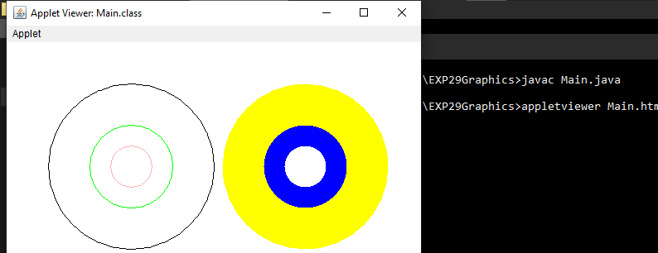

**2) Develop a program to draw: i) Square inside a circle ii) Circle inside a square**

**CODE:**

import java.applet.*;  
import java.awt.*;  
  
public class Main extends Applet {  
 public void paint(Graphics g) {  
 g.setColor(Color.black);  
 g.drawOval(50, 50, 100, 100);  
 g.drawRect(65,65, 70, 70);  
 g.drawRect(200, 50, 100, 100);  
 g.drawOval(200, 50, 100, 100);  
 }  
}

**OUTPUT:**

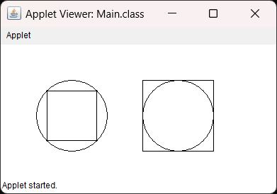

**3) Drawing basic shapes in applet**

**CODE:**

import java.applet.*;  
import java.awt.*;  
public class Main extends Applet {  
 public void paint(Graphics g) {  
 g.setColor(Color.black);  
 int[] xPoints = new int[] {100, 200, 150};  
 int[] yPoints = new int[] {100, 100, 200};  
 g.drawPolygon(xPoints, yPoints, 3);  
 g.drawOval(250, 100, 100, 50);  
 g.drawOval(250, 150, 100, 50);  
 g.drawLine(250, 125, 250, 175);  
 g.drawLine(350, 125, 350, 175);  
  
 g.drawRect(250, 300, 100, 100);  
 g.drawRect(200, 250, 100, 100);  
 g.drawLine(250, 400, 200, 350);  
 g.drawLine(250, 300, 200, 250);  
 g.drawLine(350, 300, 300, 250);  
 g.drawLine(350, 400, 300, 350);  
 }  
}

**OUTPUT:**

